

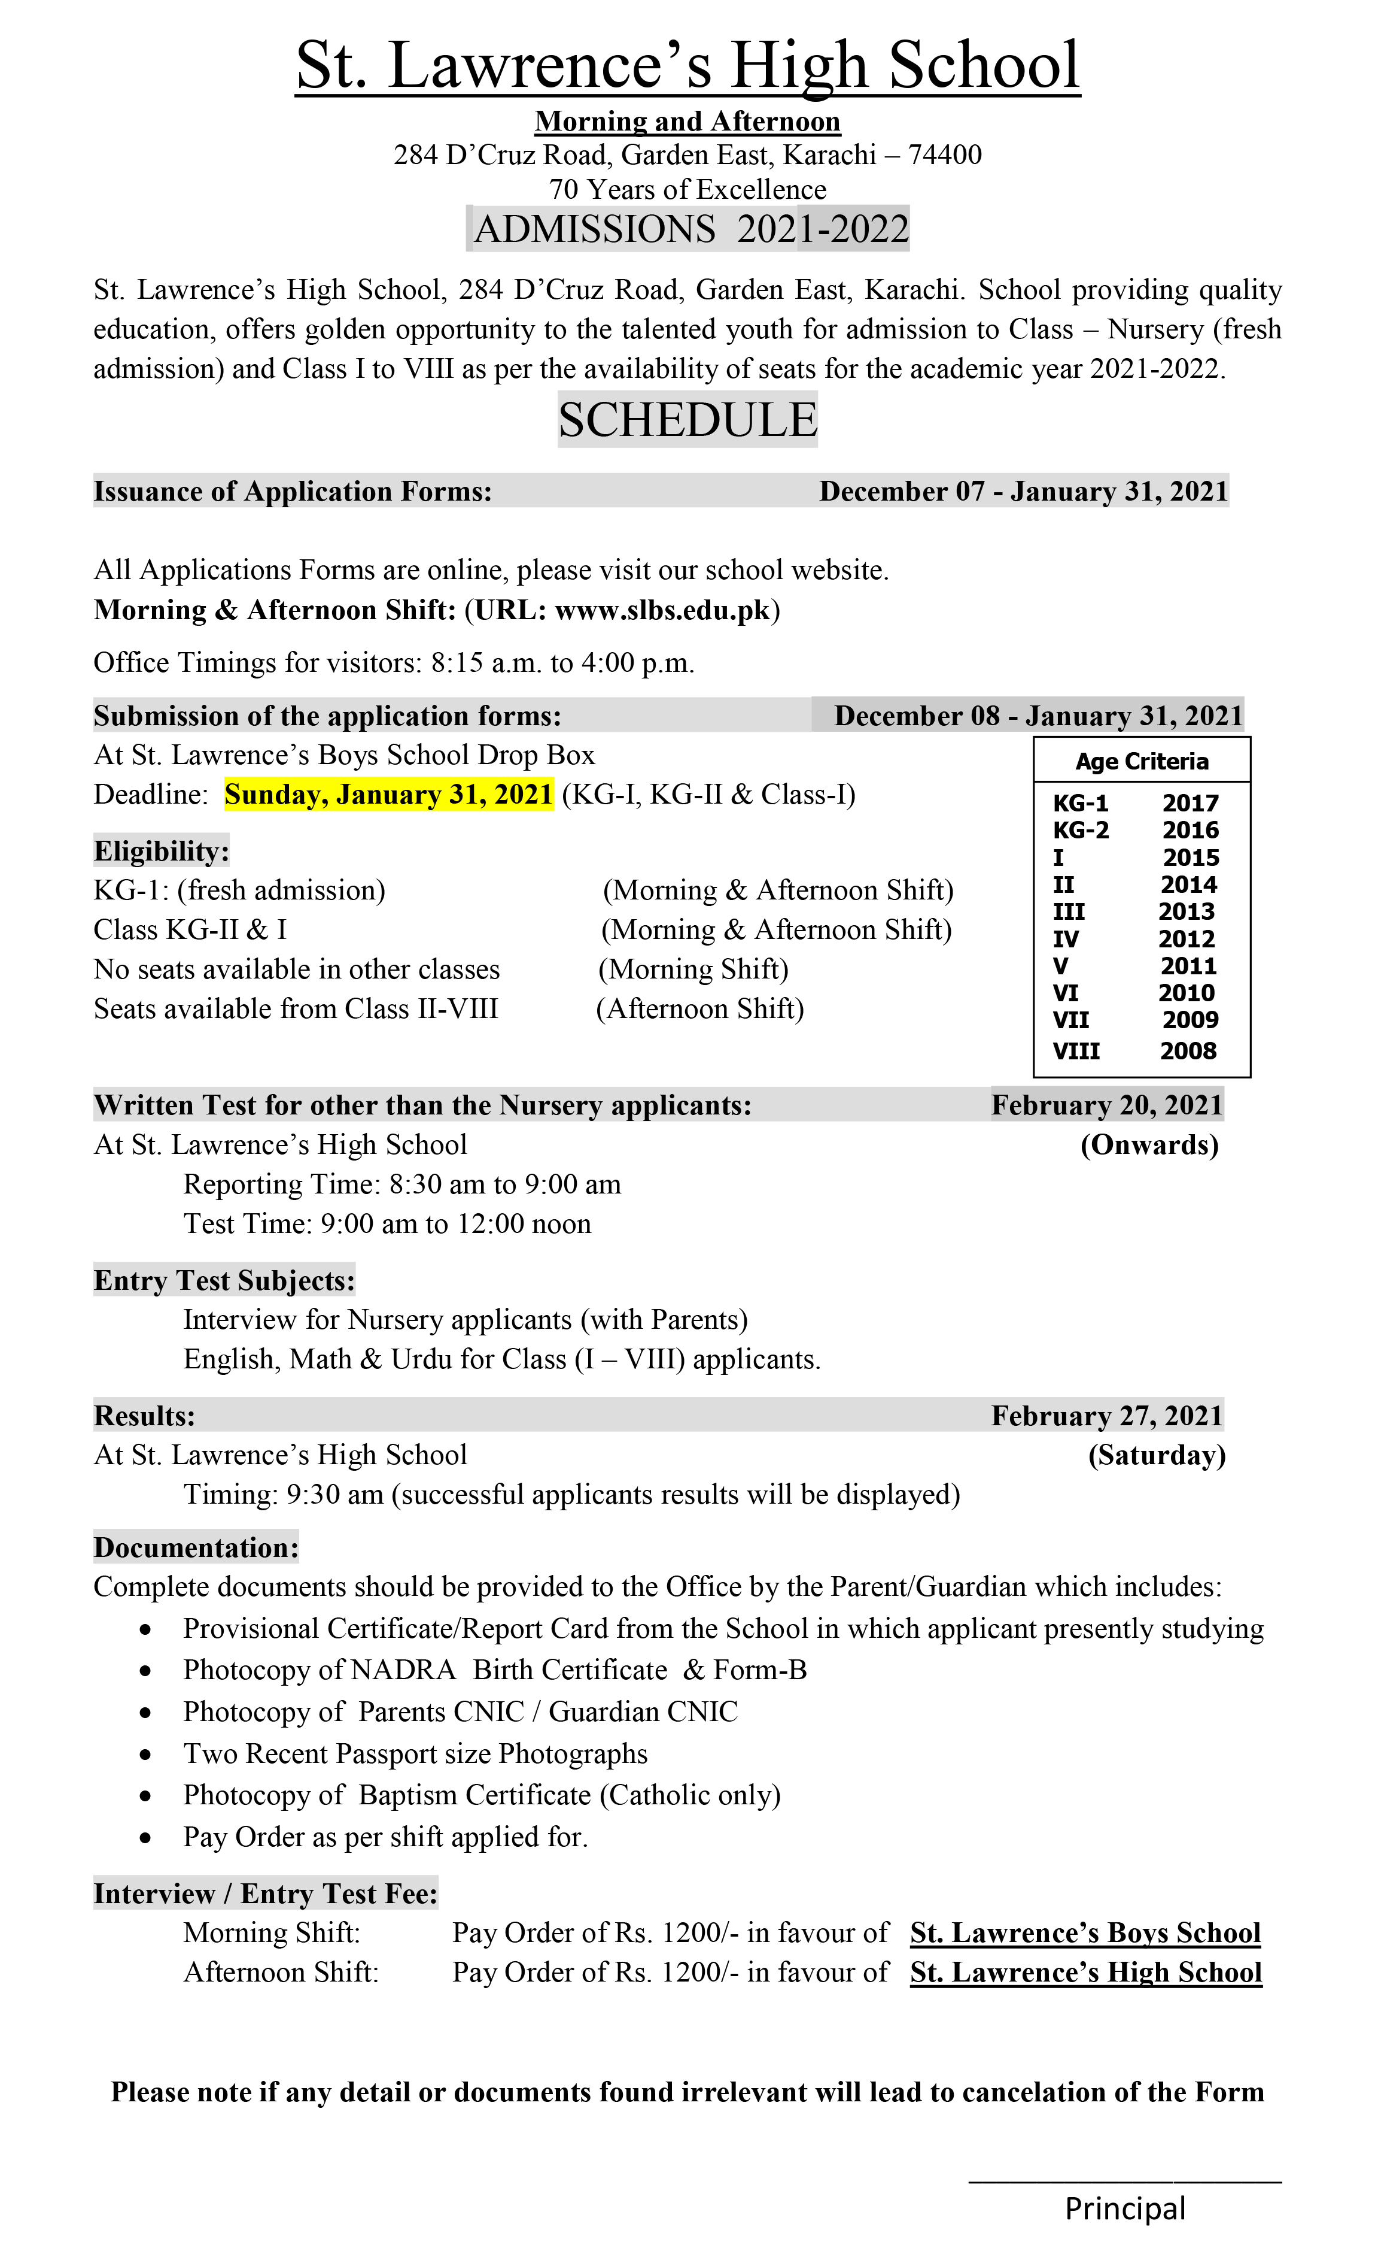



The school was in the beginning known as St. Patrick’s School, Cincinnatus Town branch. The school was founded in 1950 by Rev. Mgr. Victorno Fernandez who was then the Parish Priest. The School began in the Parlour of the Parish House for boys. The change to the present name came at a later date i.e. in May 1951. At that time, the school had six large airy class rooms. In 1951.

Rev. Fr. Francis D’ Souza was appointed principal of St. Lawrence’s Boy’s School. He extended the school towards Pedro D’Souza Road and built the first and second storey, covering the then parish house and the adjacent class room. By end of 1952, the new floor was ready for occupation. The school had now advanced to class VII and it had accommodations for the Teacher’s Common Room and Office. In 1954 Rev. Fr. Joshua Sterko becomes the Principal, who had built the new Parish house. In each of the next two years, the school took a step forward, advancing to class IX at the beginning of the scholastic year 1954 – 1955. It was towards the

end of year that the school was visited by representatives of the Catholic Board of Education. In 1962, Rev. Peter Canisus Mascrenhnas was appointed the school Principal of St. Lawrence’s Boys School. There were 40 pupils in each class with only one section. In the years that followed since then, the School took great strides forward, and the competence, dedication and unity of the staff contributed immensely to the growth of the school.



|  |  |  |  |  |  |  |  |  |  |  |  |  |  |  |  |  |  |
| --- | --- | --- | --- | --- | --- | --- | --- | --- | --- | --- | --- | --- | --- | --- | --- | --- | --- |
| **St. Lawrence’s High School, shares the following commitments.**   * We believe in the unique presence of God in each individual and in the value and the fundamental worth of each individual. * We believe in a holistic and balanced education aimed at the whole person, with a happy environment where the individual is respected and the individual is sensitive to the needs of the group. * We believe in educating our students for life. * We believe that education is primarily the role of the parents and the school is only complementary and can only accomplish its mission if it works in partnership, Viz: Home, Staff, and Students. * We believe in inculcating human and positive values. * We believe in encouraging the pursuit of excellence in all areas of school life. * We believe in a fully committed professional staff.     [**Events and Activities**](http://www.slbs.edu.pk/activities.html)   |  | | --- | | **The students activities are organized by the management and the staff. Such innovative ideas as science exhibition, millad, debates, colour day, sports, dramas, singing, girl guides, elocution contest, sports day, annual award day and computer exhibition They serve to broaden the students' horizon. Emphases is also laid on responsible citizenship.** |  |  |  |  |  | | --- | --- | --- | --- | |  |  |  |  | | **New Year Christmas Party** | **Nursery Fruit Day** | **Teachers Christmas Party** | **Eid-Milad-un-Nabi (S.A.W)** | |  |  |  |  | | **Social Studies Exhibition** | **Debate Contest** | **Scouts Performance** | **Speech Contest** |   THE STUDENTS COUNCIL: The entire student's body elects the School Head Boy, Assistant Head Boys, House Prefectst, Prefects of their houses.There are four houses Iqbal, Latif, Liaquat and Jinnah.Throughout the year there are co-curricular actives arranged among these houses. |